Motorcycle Rental System

Project Idea:

Running a motorcycle rental business comes with its own set of challenges. From customer records to reservations to bike availability, it's a difficult process if you don't have the right tool in the right place. The Motorcycle Rental System solves all these needs by providing a comprehensive and smooth way of managing daily operations, reducing the amount of manual work and increasing overall efficiency.
The system focuses on four main areas:
Customer management: A unified system for the smooth registration, updating and management of customer profiles. Motorcycle inventory: Tools to monitor the availability and condition of every motorcycle in circulation. Rental processing: An intuitive workflow for reservations, cancellations and returns to keep operations running smoothly. Reporting and analytics: Features to generate key insights, such as revenue analysis and motorcycle usage trends, to help managers make informed decisions.
The Motorcycle Rental System is developed on a powerful database that maintains and links information on customer data, motorcycle details and rental records. This ensures complete accuracy in tracking all transactions while increases the risks associated with manual errors.
This document provides a detailed breakdown of the system's features, capabilities and technical design. It serves as a guide to understanding how the system meets the operational needs of a motorcycle rental business, whether it's a small local shop or a growing rental company. By automating key tasks and centralising operations, the Motorcycle Rental System saves time, increases accuracy and improves the overall experience for both administrators and customers.

Database name: motorcyclerental
motorcylerental.sql

INSERT Operations:
Add Customer: Navigate to "Customers" in the sidebar, then click "Add New Customer" button. The form allows adding customer details including name, email, and license number.
Create Reservation: Navigate to "New Rental" in the sidebar then click "Create Reservation" button on a motorcycle details page.
The reservation form calculates total price based on selected dates and motorcycle rate.
SELECT Operations:
View Motorcycles: Click "Browse Motorcycles" in the sidebar to see all available motorcycles

View Motorcycle Details: From the motorcycle list, click "View Details" on any motorcycle to see its specifications and upcoming reservations.

View Customers: Click "Customers" in the sidebar to see a complete list of all customers

View Reservations: Click "Bookings" in the sidebar to see all reservations with filtering by status and date range.

UPDATE Operations:

Update Customer: From the customer list click the "Edit" button on any customer to update their information.

DELETE Operations:
Delete Customer: From the customer list, click "Delete"
System verifies no active reservations exist before deletion.

Cancel Reservation(Soft Delete): From the reservations list click "Cancel"

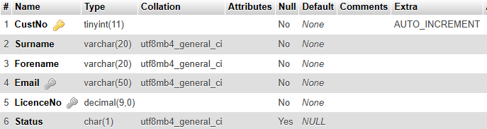
Customer Table :

Make Model Table :

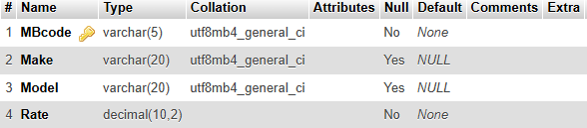

Motorcycle Table:

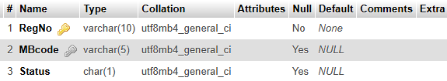

Reserevation Table:
